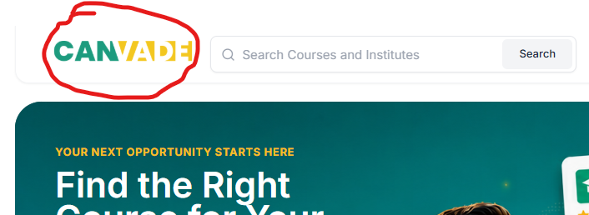
Canvade ke logo par click karne se Homepage pe redirect ho jana chahiye

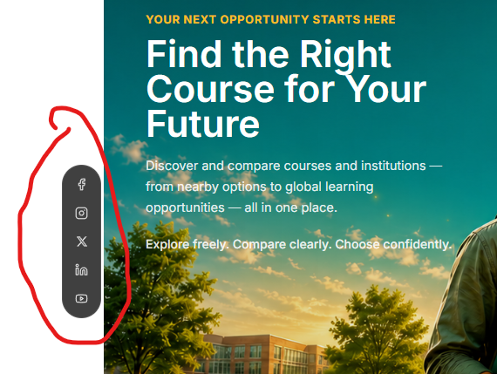
Isse hata do

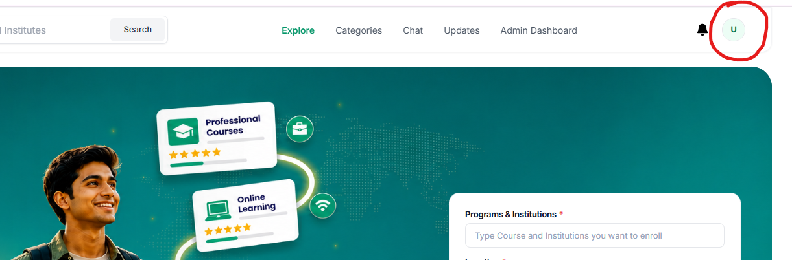
Issme logo nhi aa rha h jo upload kiya hua h

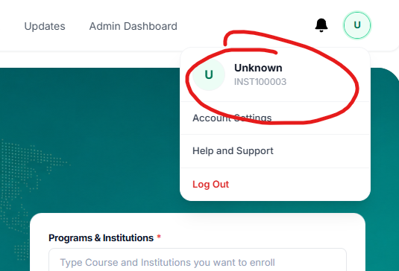
Ye Unknown dikhane lagta h kabhi kabhi

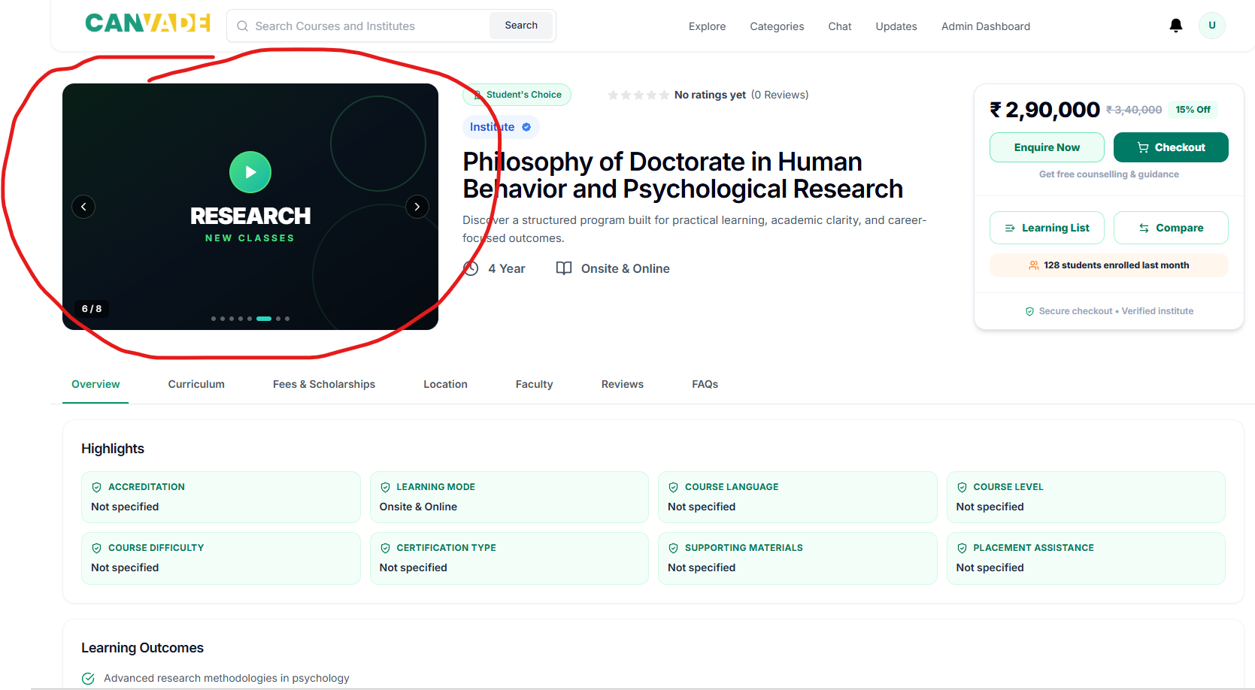
Ye purana vala UI kyu aa raha h?

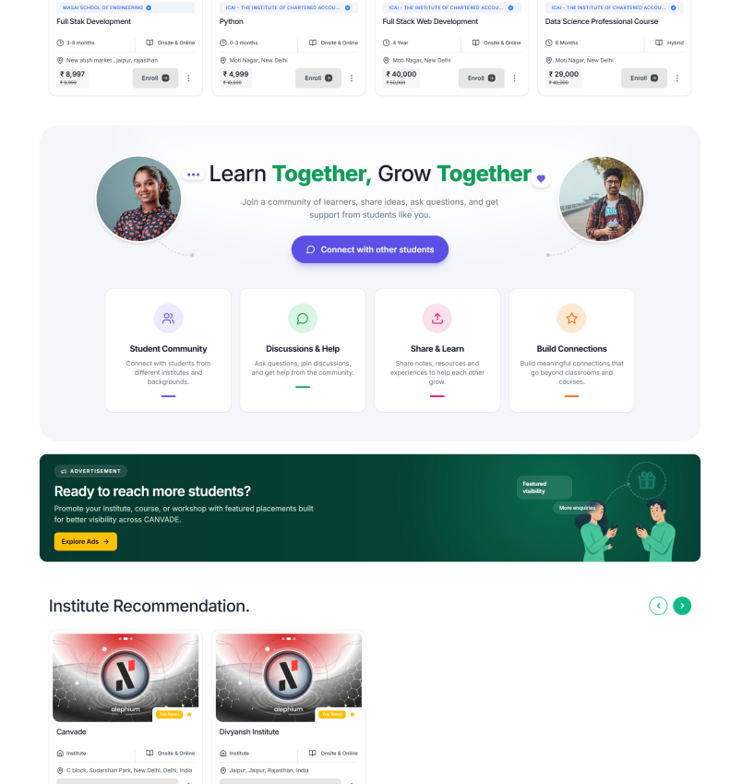

- Pure homepage ke size ko level par karna h default view me
- Sections ke bich ka visual gap thik karna h
Call karna agar smjh nhi aaega to

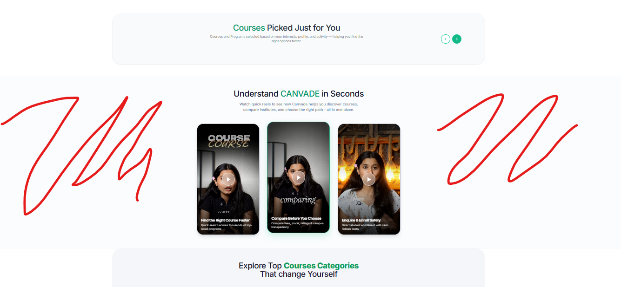
Ye background offwhite aa raha h ise hata do

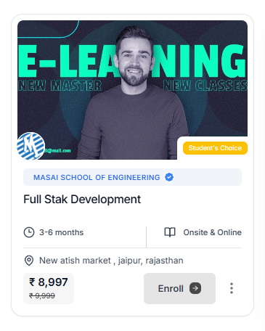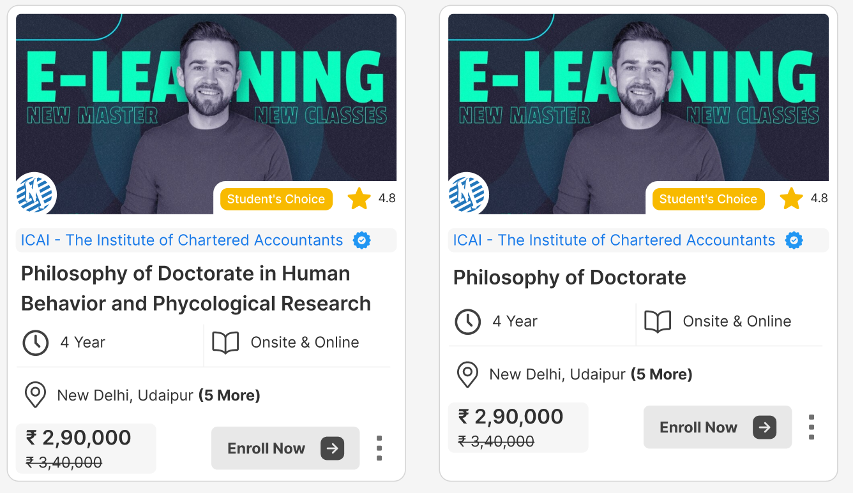
- Card ka UI or clean kardo, Exactly esa banana h isse
- Issme review vala icon nhi h vo bhi add karna h
- Location me City ke name aaenge bas
- Verify badge har jagah same hi rahega jo whatsapp group pe send kiya he ZIP file me karke. Kahi bhi alag alag nhi hona chahiye.

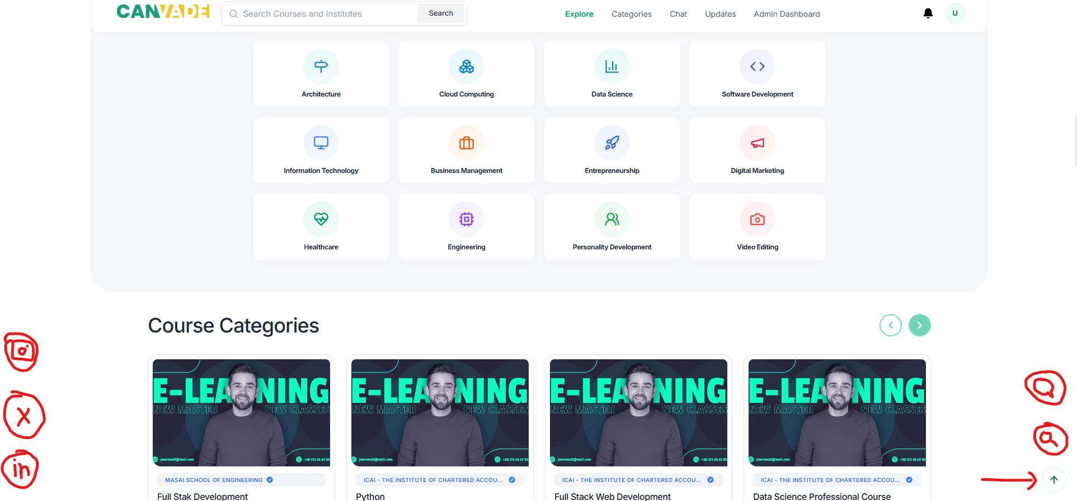
Right Back to top ke oopar 2 icons or add karne h theme same honi chahiye
- Search
- Canday AI (AI Chatbot)
Left side pe corner me same light theme
- Instagram
- X (Twitter)
- Linkedin

Back to top vala icon dikhta nhi h sahi se. sabhi icons ko thoda visible banana

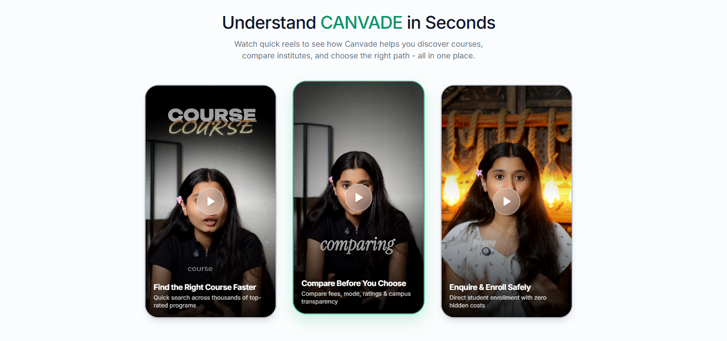
- Title me Canvade Bold kar dena
- Whatsapp par 7 videos he in 3 ko hata kar vo 7 daalni h yaha pe
- Screen pe show 3 honi chahiye or aage karne ka option de dena jese course me diya h 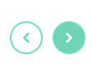

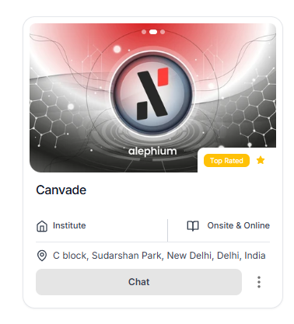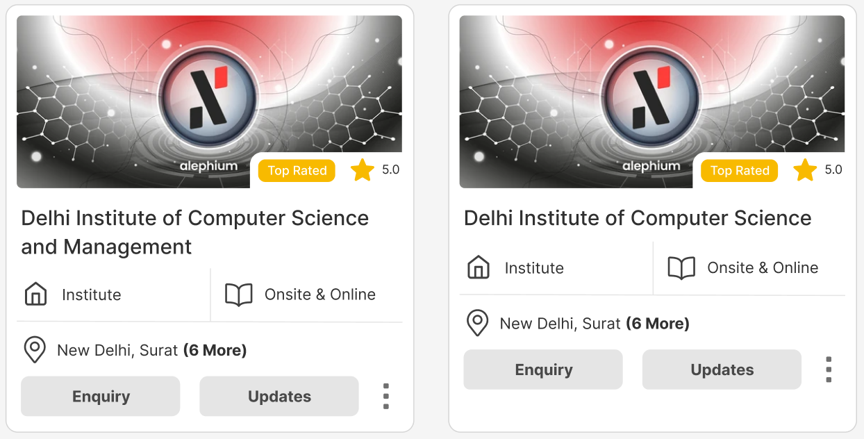
- Card ka UI or clean kardo, Exactly esa banana h isse
- Issme review vala icon nhi h vo bhi add karna h
- Location me City ke name aaenge bas
- Verify badge har jagah same hi rahega jo whatsapp group pe send kiya he ZIP file me karke. Kahi bhi alag alag nhi hona chahiye.

